

OPERATIONAL & INSTRUCTION
MANUAL
Models: U300, U1000M, U1300M
U2000, U2000M, U2100, U3000

UltraSonic LLC
P.O. Box 54081
Cincinnati, Ohio 45255
Tel: 513-502-9746
Fax: 513-702-2399

info@ultrasonicllc.com www.ultrasonicllc.com
FEATURES:

- Mechanical Model (without heater)
- Mechanical Model (with knob timer and heater)
- Digital Model (with digital time and heater)
- Power Adjustable Model
(with timer and heater, and adjustable power)

CAUTIONS

Thanks for purchasing the UltraSonic LLC Professional Cleaning System. Please read the instruction manual carefully before operation to avoid damage to the machine or any danger to personal safety, also please keep this manual for future reference.
- Ensure the power supply is in rated range before power cable is connected. Refitting is strictly prohibited! Attention that the control panel will be eroded by organic solution, strong acid, and strong alkali.
- Ensure the earth wiring is well connected before starting.
- Ensure the power key or knob is on the ‘OFF’ place before starting.
- Do not operate if the tank is empty, or the ultrasonic generator will be damaged. If heating is needed, the water level should not
- be less the 2/3.
- Please close the lid to reduce noise and pay attention to water and steam in case of burning skin while opening the lid.
- Do not relocate the machine when fluid is in the tank to avoid overflowing.
- Suggest using water- soluble liquid for benchtop ultrasonic cleaners. Strong acid or flammability cleaner is forbidden.
- Do not use machine in severe environment:
- The place where temperature changes to quickly:
- The place where humidity is too high and is easy to produce dew.
- The place where vibration or impact is strong.
- The place where corrosive gas or dust exist.
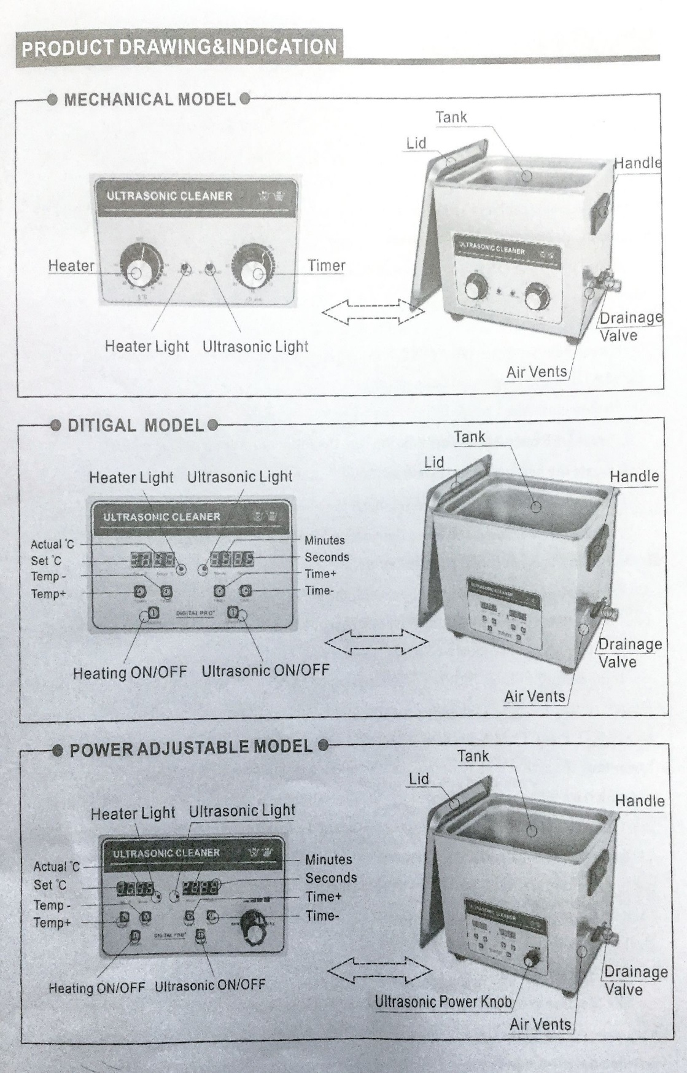
- The place where water, oil, or chemicals splash.
OPERATION PROCEDURE
- Before starting the equipment, check the machine to see if there are any loose parts.
- Keep the unit on a stable and flat working platform in a dry cool environment.
- According to the size and quantity of washing objects, add a little bit of detergent in the tank which can help improve the cleaning effect. (empty tank working is forbidden!)
- Ensure correct power and switch connect before starting the equipment.
- OPERATION INSTRUCTIONS: (MECHANICAL MODELS)
- Start (UltraSonic), clockwise rotate to choose the time you required between 0-30 minutes. When the indicator light is on and makes a “ZIZI” sound, it shows ultrasonic operation is working.
- If need heating, start (HEATING) to adjust required temperature, normally 40-60C is the best. (Heating is optional upon needs)
- To stop cleaning:
- Press OFF once, the ultrasonic will stop running, the indicator light will also be off.
- Rotate the heating knob to “OFF”, the indicator light will also be off.
- Switch off the unit and disconnect the power.
- Empty out the liquid and clean the tank and the unit with a clean cloth for the next use.
- OPERATION INSTRUCTIONS: (DIGITAL MODLES)
- Timer setting: When power is connected, the default setting is “05:00”. Press TEME+ once will increase time by 1 minute; press TEME+ once more and time will decrease by 1 minute. (Free choice and digital countdown control)
- Temperature settings: (heating is optional upon needs): When power is connected the default, setting is “50C” and actual is room temp., press temp+ once, and it’ll increase temperature by 1C; Press temp- once, and it will decrease by 1C. If the setting temperature is lower than the actual tank temperature, the operation will stop automatically. When the temperature rises to the setting temperature, the indicating light goes off. When ultrasonic works, two temperature screens show set temperatures and actual temperature has been reached.
- After setting the time and the temperature, press ON/OFF once, the equipment will work automatically. Press ON/OFF again, the work process will stop. Then switch off the unit and disconnect the power supply, empty out the liquid and clean the tank and the unit with clean cloth for next use.
- ADJUSTING POWER:
- The function is only available for the power adjustable models! Rotate SLOWLY the power knob clockwise to increase the power from 40% to 100%, and counter-clockwise SLOWLY is to decrease sonic power.

MAINTANCE
- The unit must be opened by an authorized specialized person only for maintenance purposes only.
- Clean the contaminant in the tank frequently.
- Please see next page for possible issues, causes, and solutions.
No. | PROBLEMS | CAUSES | SOLUTIONS | OTHER
1. | No ultrasonic | - Power supply not connected.  - Fuse broken.  - Cable short circuit  - Transducer short circuit  - PCB board broken | - Check and plug power switch.  - B. Check the fitted power supply and change the same specification fuse.  - C. connect fitted cable or replace with new.  - Inquiry our service engineer
2. | Time control failure | - Timer knob out of control  - B. Timer failure  - Other reasons | - Loosen or tighten the screw.  - Replace timer or digital panel.  - Inquiry our service engineer
3. | No Heating | - Heater power switch bad linkage  - Fuse burns out.  - Heating pad burns out  - Digital display board out of control | - Check heating plug and connect well.  - Change the same specification fuse.  - Replace bad heating pad.  - Check broken part and change it. | Suggestion:  50-60c
4. | Temperature control failure | - Thermostat loose.  - Thermostat tube broken.  - Digital display out of control. | - Fasten the thermostat header.  - Replace thermostat.  - Check broken part and change it.
5. | Not cleaning well | - Not strong ultrasonic cleaning.  - Too high too low liquid surface.  - Too high too low temperature.  - Not suitable cleaning liquid. | - Connect ultrasonic button and adjust.  - Adjust liquid into best surface.  - Adjust temp. into most fitted.  - Stop and switch off power supply. | Suggestion:  50-60c
6. | Electric leakage | - Customer side not grounded.  - Machine not grounded | - To ensure grounded.  - Check if machines earth wire is loose.
7. | Other problems | Contact our service department!

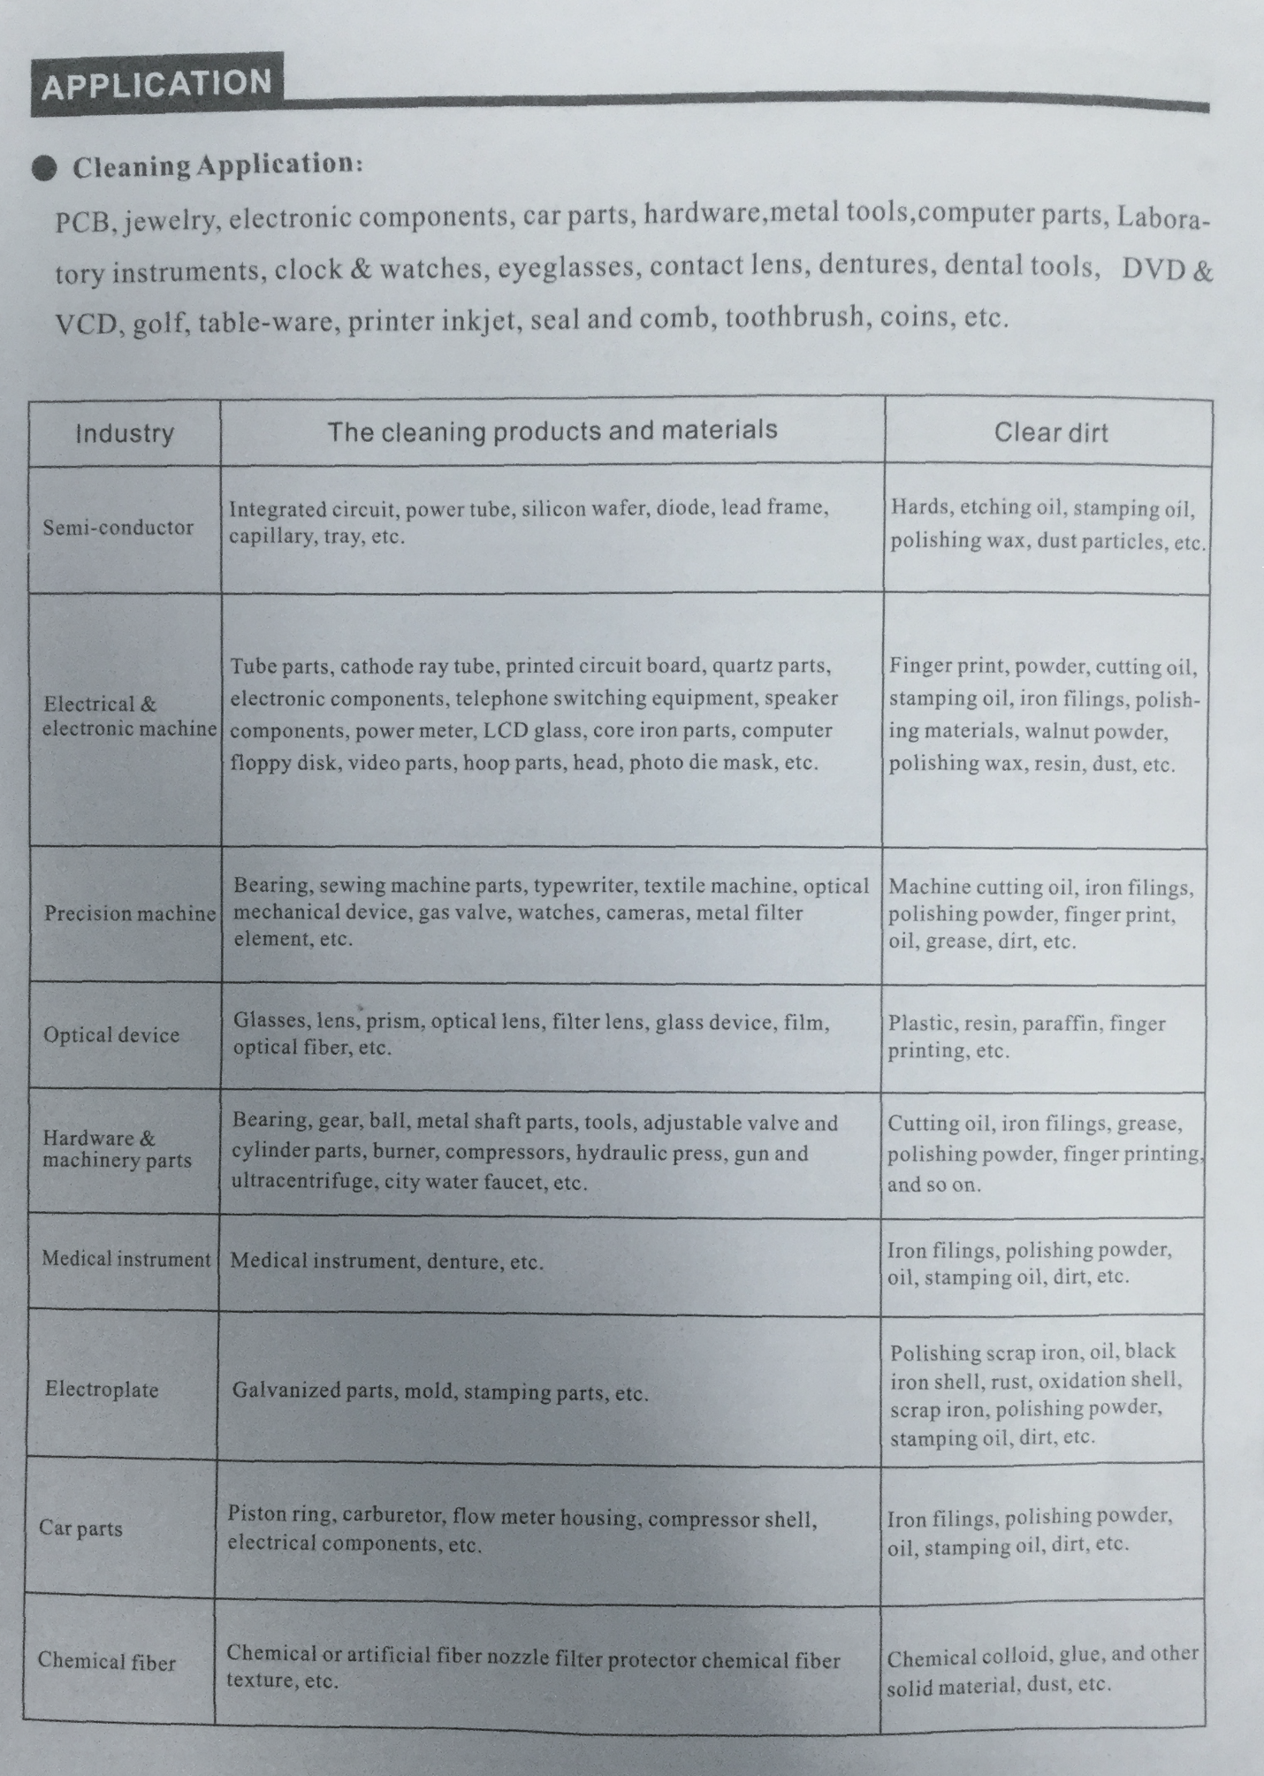

Specifications:

MODEL | U1000M | U1300M | U2000 | U2000M | U1300 | U1000
TANK | 11.8*5.9*3.9” | 12.9*11.8*5.9” | 19.6*11.8*7.8” | 19.6*11.8*7.8” | 12.9*11.8*5.9” | 11.8*5.9*5.9”
DEPTH | 3.9” | 5.9” | 7.8” | 7.8” | 5.9” | 5.9”
UNIT | 12.7*7*8.8” | 14.1*12.7*11.2” | 20.8*12.7*12.7” | 20.9*12.7*12.7” | 14.1*12.7*11.2” | 12.7*7*11”
VOLUME | 1.1 Gallons | 3.9 Gallons | 7.9 Gallons | 7.5 Gallons | 3.9 Gallons | 1.7 Gallons
CONTROLS | Manual | Manual | Digital | Manual | Digital | Digital
POWER | 120v@3A | 120v@5A | 120v@8A | 120v@8A | 120v@5A | 120v@3A
SONICPOWER | 180 Watts | 360 Watts | 600 Watts | 600 Watts | 360 Watts | 180 Watts
FREQUENCY | 40 KHz | 40 KHz | 40 KHz | 40 KHz | 40 KHz | 40 KHz
HEAT | 200 Watts | 300 Watts | 500 Watts | 600 Watts | 300 Watts | 200 Watts
DRAIN | n/a | Yes | Yes | Yes | Yes | Yes
MACHINE WEIGHT | 6.6 lbs. | 16.5 lbs. | 27.5 lbs. | 27.5 lbs. | 24.2 lbs. | 11.9 lbs.

MODEL | U2100-28 | U2100 | U3000
TANK | 21.6*15.7*13.7” | 21.6*15.7*13.7” | 31.4*11.8*15.7”
DEPTH | 13.7” | 13.7” | 15.7”
UNIT | 28.7*22.8*30.3” | 28.7*22.8*30.3” | 41.3*19.6*31.2”
VOLUME | 20 Gallons | 20 Gallons | 25.3 Gallons
CONTROLS | Digital | Digital | Digital
POWER | 120v@15A | 120v@15A | 120v@15A
SONICPOWER | 1200 Watts | 1200 Watts | 1500 Watts
FREQUENCY | 28 KHz | 40 KHz | 40 KHz
HEAT | 1000 Watts | 1000 Watts | 2000 Watts
DRAIN | Yes | Yes | Yes
MACHINE WEIGHT | 135 lbs. | 135 lbs. | 185 lbs.

NOTES:

